
ISO22301 Toolkit: Version 6
©CertiKit

Progress Report
Implementation guidance
The header page and this section, up to and including Disclaimer, must be removed from the final version of the document. For more details on replacing the logo, yellow highlighted text and certain generic terms, see the Completion Instructions document.

Purpose of this document
This document gives a regular overview of the progress of an ISO22301 implementation project.

Areas of the standard addressed
The following areas of the ISO22301 standard are addressed by this document:
- All

General guidance
It’s important to keep top management informed about the progress of the BCMS, including what’s been achieved, what’s still to be done and any issues that need resolution. This document is intended as a regular report, perhaps weekly, and could be supplemented with a more detailed report, perhaps based around the gap assessment, on a monthly basis.

Review frequency
This document is intended to be used until certification.

Document fields
This document may contain fields which need to be updated with your own information, including a field for Organization Name that is linked to the custom document property “Organization Name”.
To update this field (and any others that may exist in this document):
- Update the custom document property “Organization Name” by clicking File > Info > Properties > Advanced Properties > Custom > Organization Name.
- Press Ctrl A on the keyboard to select all text in the document (or use Select, Select All via the Editing header on the Home tab).
- Press F9 on the keyboard to update all fields.
- When prompted, choose the option to just update TOC page numbers.
If you wish to permanently convert the fields in this document to text, for instance, so that they are no longer updateable, you will need to click into each occurrence of the field and press Ctrl Shift F9.
If you would like to make all fields in the document visible, go to File > Options > Advanced > Show document content > Field shading and set this to “Always”. This can be useful to check you have updated all fields correctly.
Further detail on the above procedure can be found in the toolkit Completion Instructions. This document also contains guidance on working with the toolkit documents with an Apple Mac, and in Google Docs/Sheets.

Copyright notice
Except for any specifically identified third-party works included, this document has been authored by CertiKit, and is ©CertiKit except as stated below. CertiKit is a company registered in England and Wales with company number 6432088.

Licence terms
This document is licensed on and subject to the standard licence terms of CertiKit, available on request, or by download from our website. All other rights are reserved. Unless you have purchased this product you only have an evaluation licence.
If this product was purchased, a full licence is granted to the person identified as the licensee in the relevant purchase order. The standard licence terms include special terms relating to any third-party copyright included in this document.

Disclaimer
Please Note: Your use of and reliance on this document template is at your sole risk. Document templates are intended to be used as a starting point only from which you will create your own document and to which you will apply all reasonable quality checks before use.
Therefore, please note that it is your responsibility to ensure that the content of any document you create that is based on our templates is correct and appropriate for your needs and complies with relevant laws in your country.
You should take all reasonable and proper legal and other professional advice before using this document.
CertiKit makes no claims, promises, or guarantees about the accuracy, completeness or adequacy of our document templates; assumes no duty of care to any person with respect its document templates or their contents; and expressly excludes and disclaims liability for any cost, expense, loss or damage suffered or incurred in reliance on our document templates, or in expectation of our document templates meeting your needs, including (without limitation) as a result of misstatements, errors and omissions in their contents.

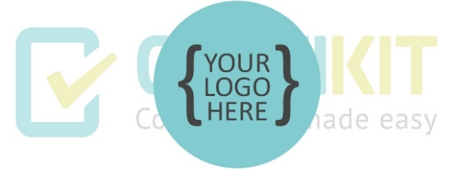
Progress Report

Date:

Distribution
NAME | TITLE |  | PROJECT ROLE
Weeks to certification audit:
Estimated percentage conformity:
Progress summary:
Tasks completed last week:
Tasks planned for the coming week:
Issues requiring resolution:

Status against milestones
MILESTONE | TARGET DATE | STATUS
Project initiation
Initial certification assessment:
Final certification audit:

The chart below is intended to give a general indication of the degree of conformance of each of the ISO22301 processes [from ISO22301 Gap Assessment]:

Figure 1: ISO22301 conformity chart from the Gap Assessment spreadsheet

